🡪Update local cache

Python-devel: Libraries and source.. In future if we want to build any plugin

Pip: Plugin manager or Module manager for python...

**These dependencies are required for some of modules, because Ansibe run playbooks that are written in Python**

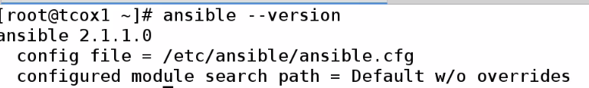

**Change Config:**



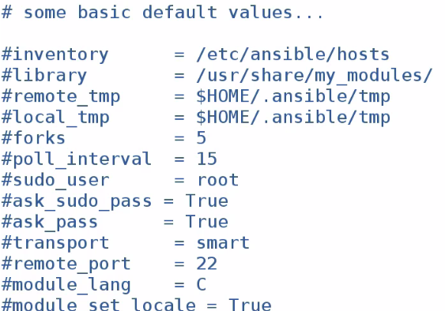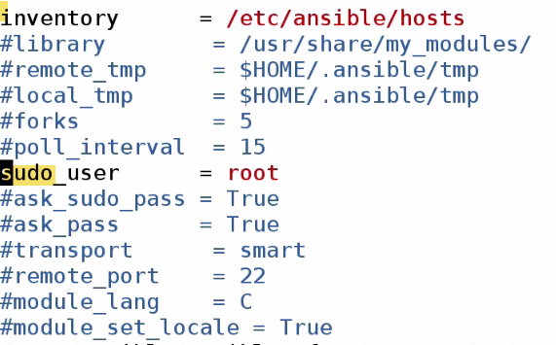

**Inventory: We can specify other inventory locations. In this case, we are going to have global Inventory hosts file.**

**When we run commands as sudo, then it will run as root user.**

**There are also ssh values, module, bash values in this file.**

**As there is no daemon running in Ansible, not required to restart. Ansible will read config file.., every time we run Ansible cmds.**

**When we run Ansible cmds or playbooks, we run against Nodes (identified by name). Names are like DNS entry, indicated by values in hosts file.**

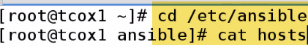****

**We created 3 groups**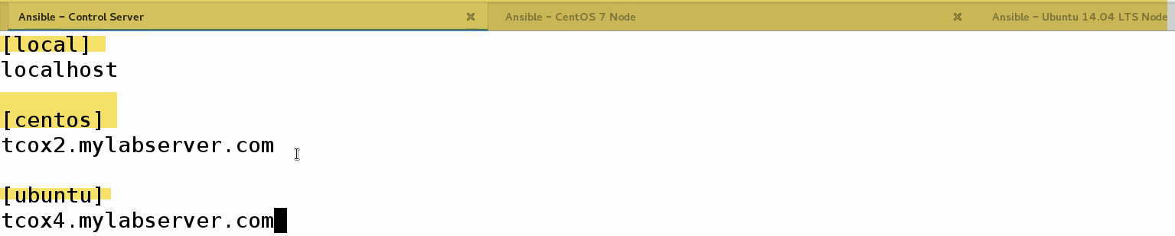

**We typically run Ansible commands as sudo user**

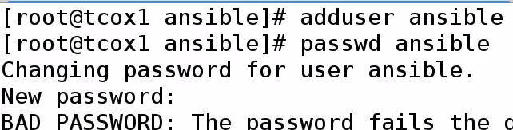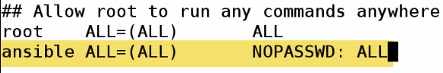**We need to create user accounts on each of nodes that we are going to manage with Ansible**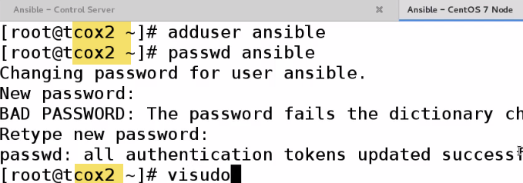

Since we operate over ssh, and we will not be passing password using sudo.

We can password..however we run playbooks as part of cron job, Jenkins job..So we don’t want to provide password.

**We have to setup ssh keygen:(WRONG BE ANSIBLE UER)** 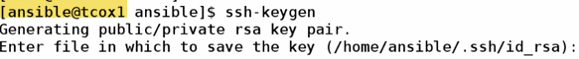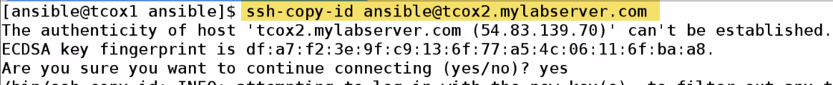

Now to Ubuntu: 

For localhosts: We need to copy-id to ourselves..Otherwise ssh to localhost fails without keyexchange..

**Even for connection to localhost will ask for password**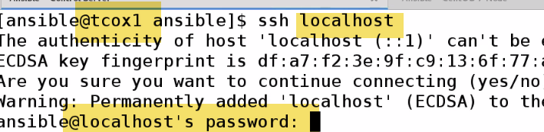



**Summary:** Installed Ansible and its dependencies

Made cople changes to Ansible.cfg

As there is no daemon running in Ansible, not required to restart. Ansible will read config file.., every time we run Ansible cmds.

Created hosts file, with 1 node in each group

Created Ansible user, and provided sudo user.

Exchanged keys nodes as well as local(Ansible server functions as local node) and nodes.

-🡪 Ansible Documentation:

**Docs.Ansible.com**🡪Owned by redhat..Certifications: 2---Ansible, Ansible Tower(Enterprise)—Reporting, graphing, with support

We already setup our inventory: /etc/hosts file which contains groups of individual nodes we may choose to run playbooks against... Inventory can contain Individual nodes, groups, patterns etc.

We can Ranges of Ips, ports, names..

Playbooks: Text file that contains YAML formatted options that tells Ansible what to do, what modules to run, what options to use in order to connect to Nodes to perform various work.

Playbooks run remotely through SSH on remote server..

Update Cache(repo) and install particular pkg: foo.

We can say install if absent, install update-to date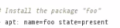

We will see simpler: install/update/remove users…

Let’s say I need to update simple config. On whole bunch of servers in my env.. I only want to run 1 command and update all. ..No need to complex like login to using ssh and udate all , setup..

As long as SSH setup, user and key exchange, can update/install pkgs across bunch of servers, And also. What distribution it is...

-🡪 Running Ansible Commands:

Cmd: Going to use Ansible module or not going to use module.

To do something on group of nodes or pull info. About node. This is similar to running playbook; however playbook is constructed in file..

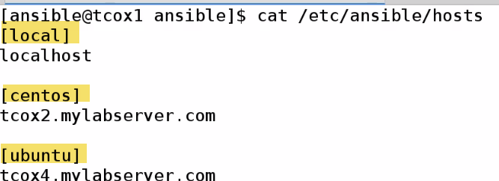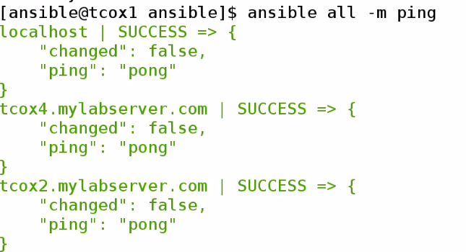all-> Run on all(default for all nodes on hostsfile)

-a🡪Run an arbitrary command (whatever is behind this parameter)

-m🡪Use following module (like ping). 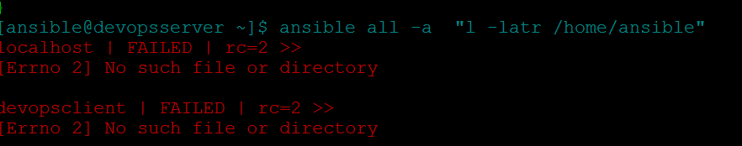

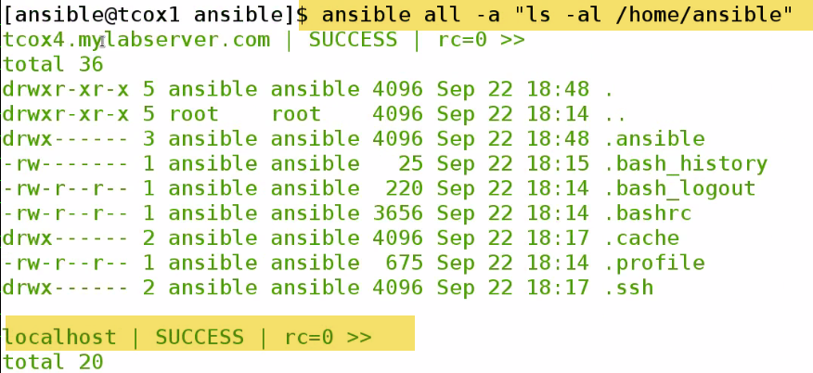

0-> success

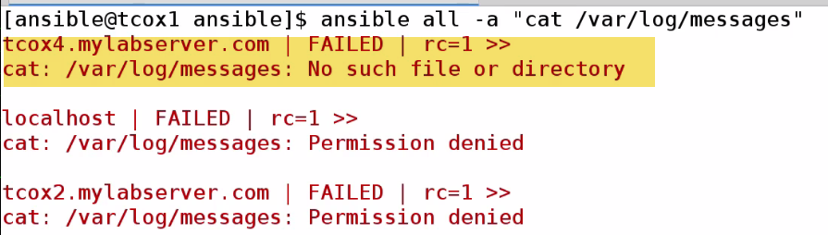

Root can only cat.. DO sudo

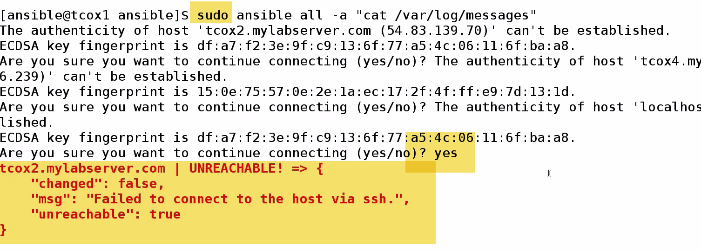

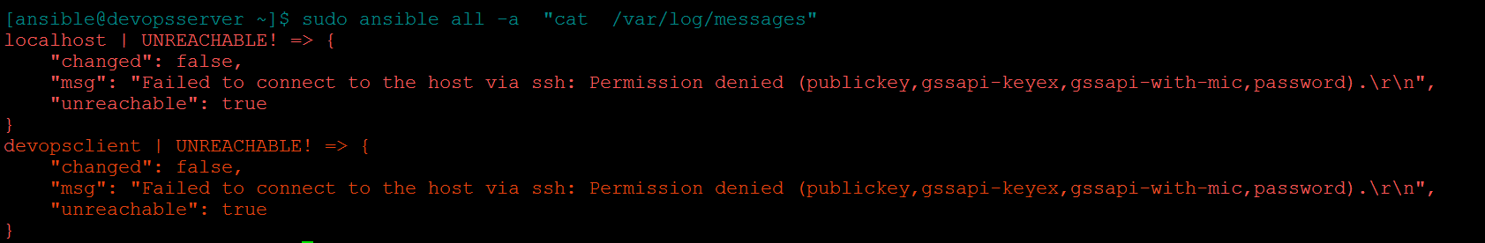

1.) It is asking for prompt

2.) Failing to connect using SSH??

Because, when I do sudo, it is trying to be as root user. I didn’t exchange root keys with individual nodes.

How to run privileged commands with Ansible user???

Why did we setup visudo (/etc/sudoers) –NOPASSWD???..Because there is facility in Ansible to use sudo root if we pass -s ..It will run command-elevating previlage of Ansible user to sudo(ASSUMING WE SET SUDO PRIVILEGES UP) on remote keys..And as we exchanged keys and indicated NOPASSWD…

-s

🡪Only on local

**COPY**

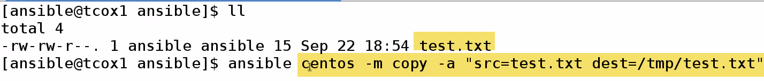

I have file test.txt

Execute command against Centos group(1 node) using module COPY with following attributes

Copying src file test.txt to dest file test.txt in /tmp dir.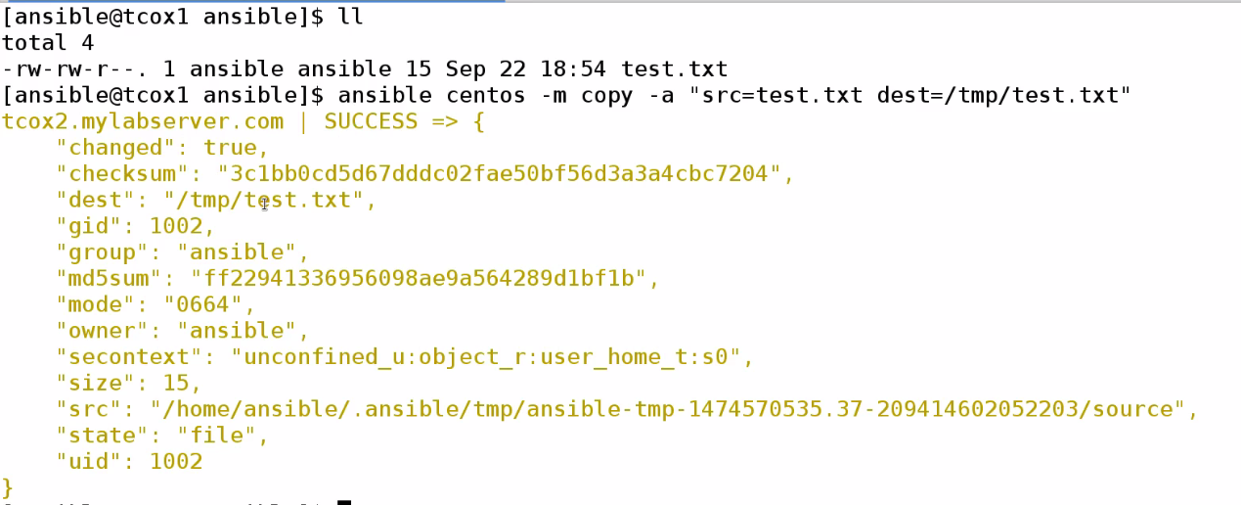

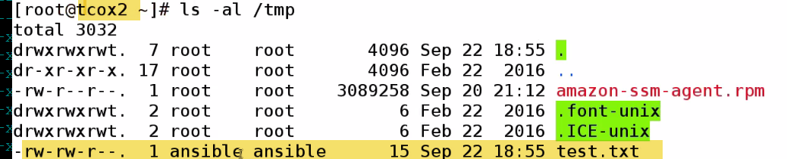

On Centos, see on /tmp test.txt created by Ansible user

🡪**Install pkgs**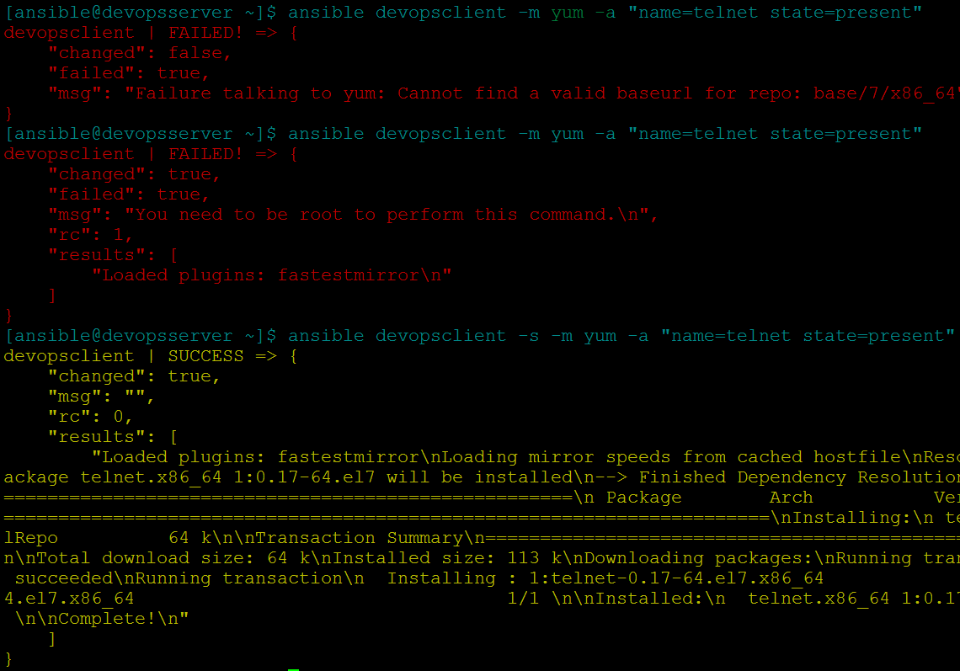

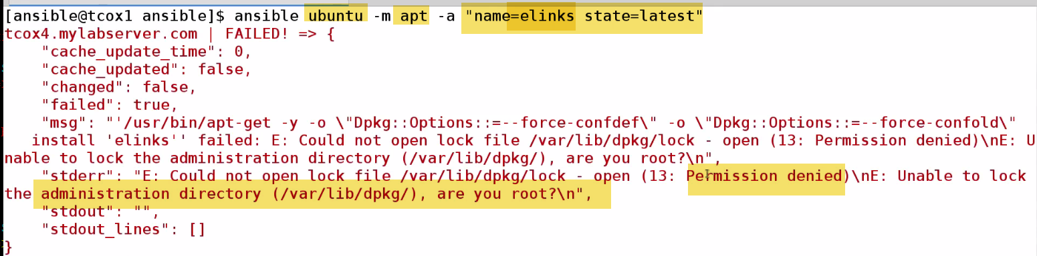

State=present🡪just install (Challenge: if we have old version of pkg, it will qualify as present, and wont get update..

**In most cases, we use latest…Use –s**

**Remove: State: Absent**



**Add User**

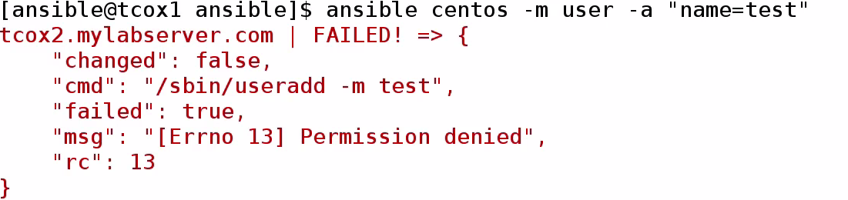

**Run a command**

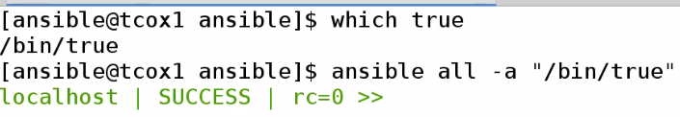

**-🡪Playbook Structure with YAML**

YAML: Key value list

Very Easy to read, which helps to define playbooks against nodes.

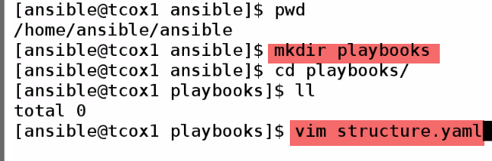

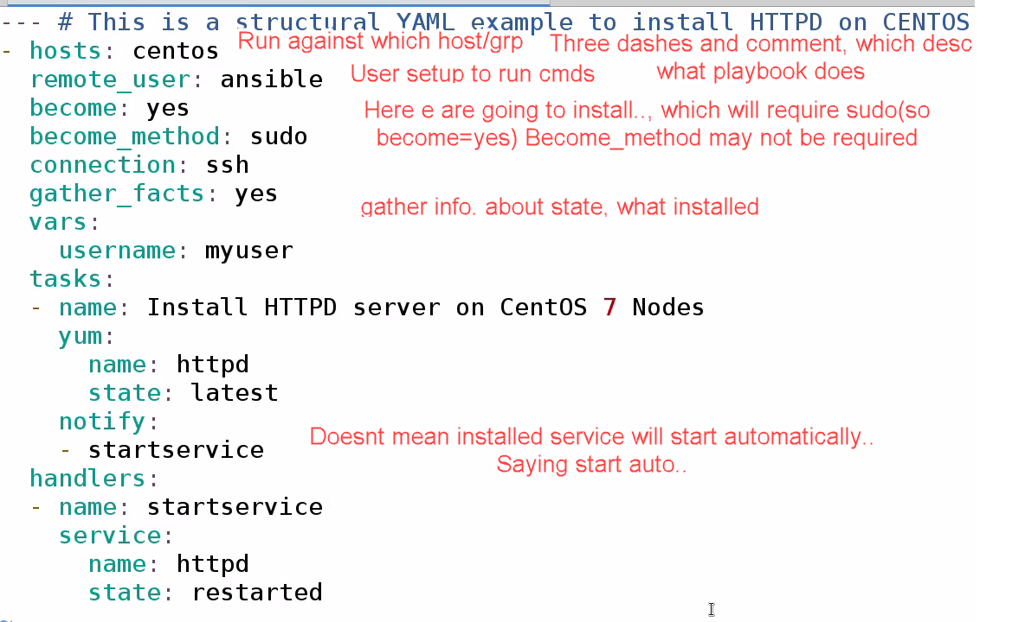

Everything is defined in sections..

Everyhing here belongs to hosts….Username belong to vars

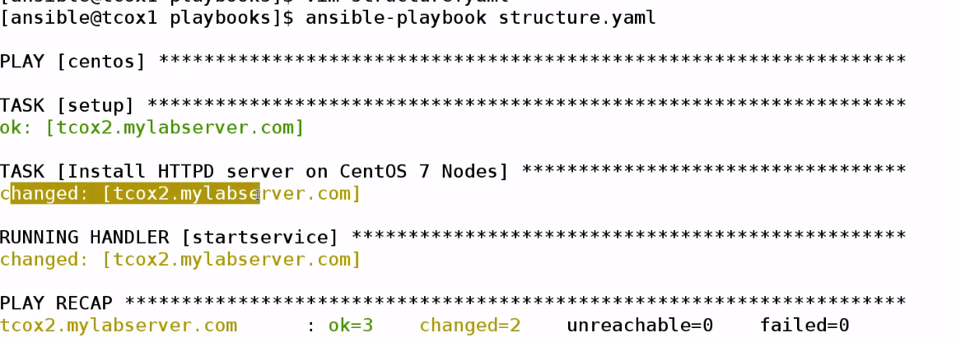

Playbook for Centos group is running..Task setup..Installing httpd—running startservice.

**2 Changes made : Install httpd, restart service**

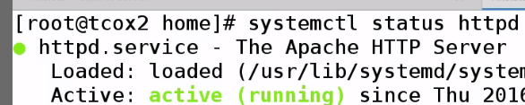

**-🡪 Gathering Facts**

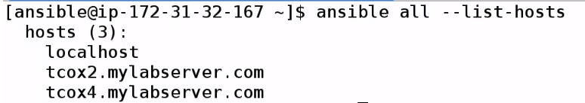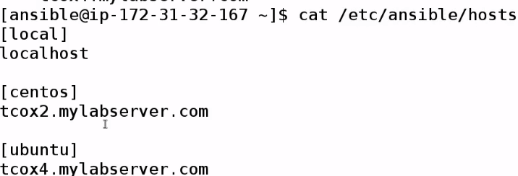

In playbook we mentioned, we can turn on or off gatheer facts

**_facts=(true) default**

Ansible needs to needs to determine someway, whether it can run plays asked to on remote nodes..

It goes and asks info. About that node..

We can explicitly get facts...if we want to..

****🡪It will gather facts by default when Ansible runs any playbook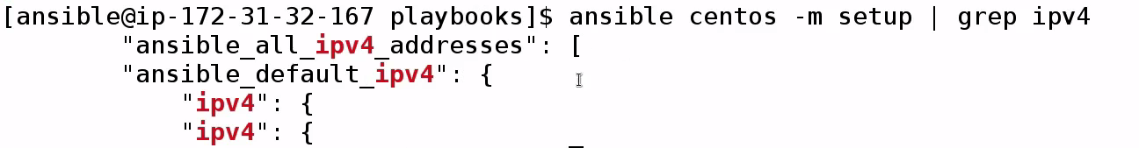

Actually lines in here..are in json -🡪 not good for grep---

FILTER SECTION THAT HAVE IPV4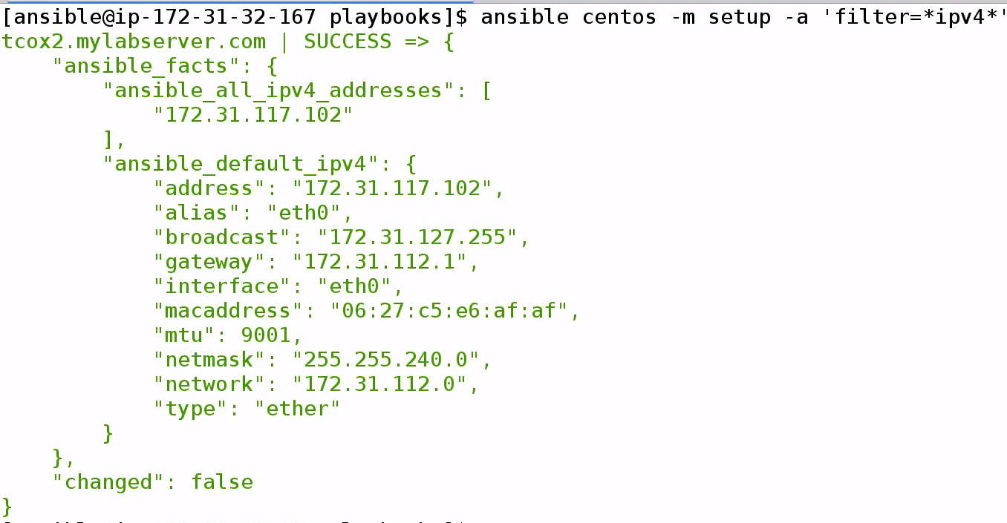

**🡪Create a localfile**

**Facts is output folder**

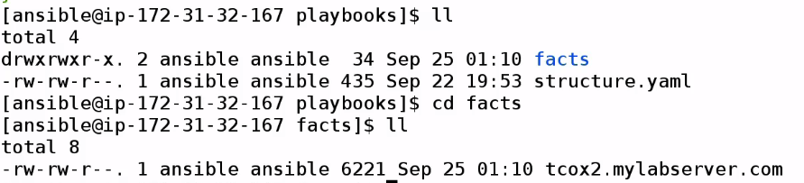

**Vim tcox2.mylabserver.com**



**Now, find key…We can use them in playbooks**

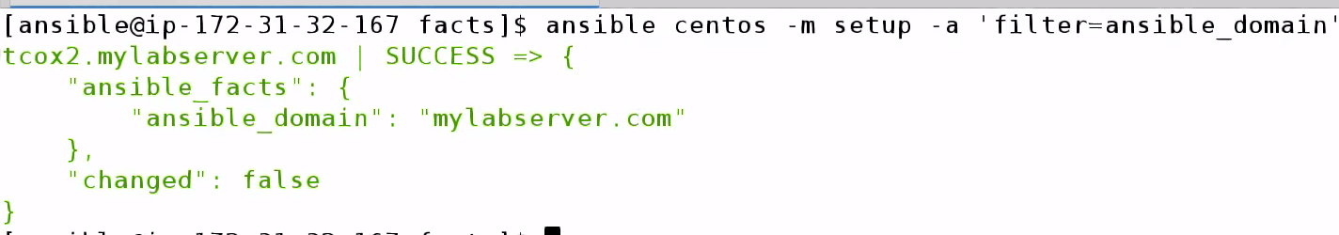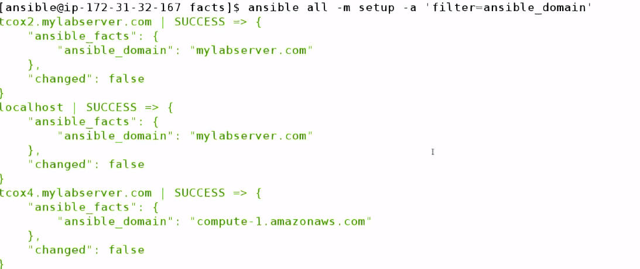

**-🡪 Variable Substitution**

**Variables can be used in playbooks in 2 ways:**

1. Variable section in playbook: So we can change once, instead of changing multiple times
2. Variable pass at run time

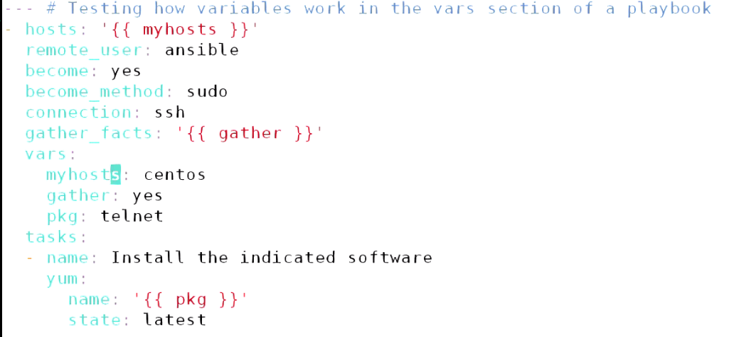

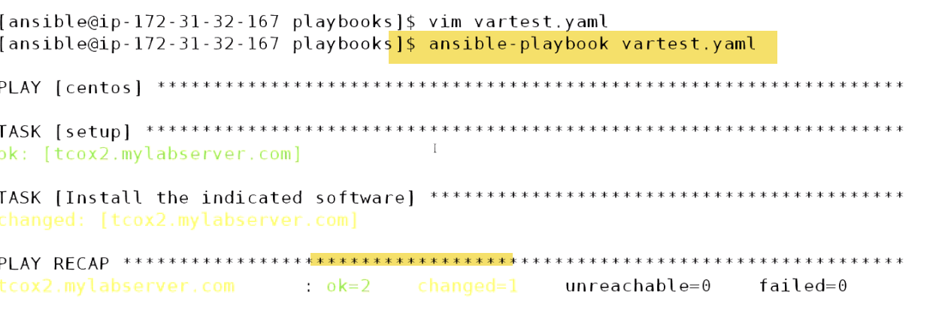



Command to centos group as sudo running yum module passing parameter telnet pkg to uninstall

1. Passing arguments

Remove variable section:

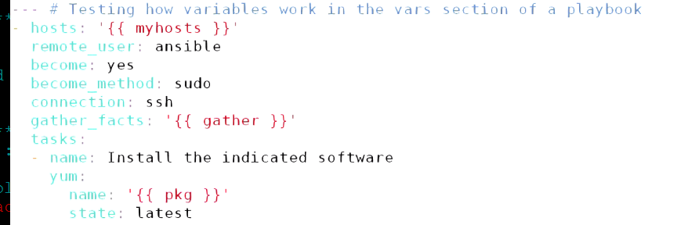



-🡪Debug Statement:

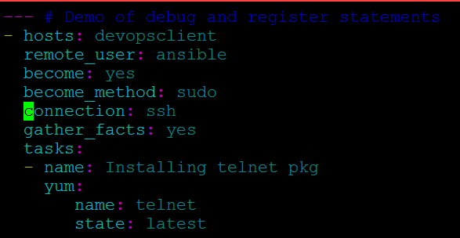

Let us say if we want to do on 100 servers or entire environment like upgrading.

I need to know:

-Which servers did not have pkg installed at all

- Which servers have software pkg updated

--If something expected happens??—I need to go to each client and check if telnet is installed

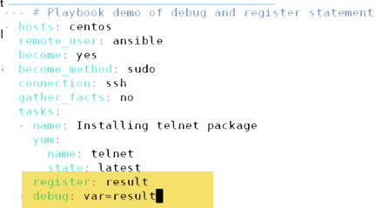

**-🡪Notifications and Handlers**

Ability to determine: When something run regardless of other event---Called as Notification and Handling.

While executing tasks within playbook and execute some control over(no need to use conditions) but it’s basicalaly saying if this thing run.. Run another thing. If 1st thing didn’t run..other will not run..

**Named as notification because: It fires off notification for section called as handler section to handle.**

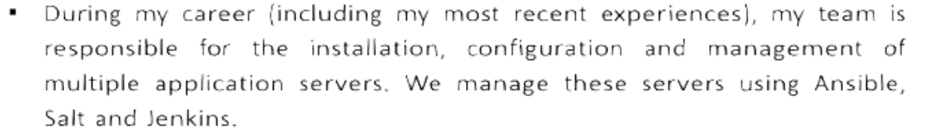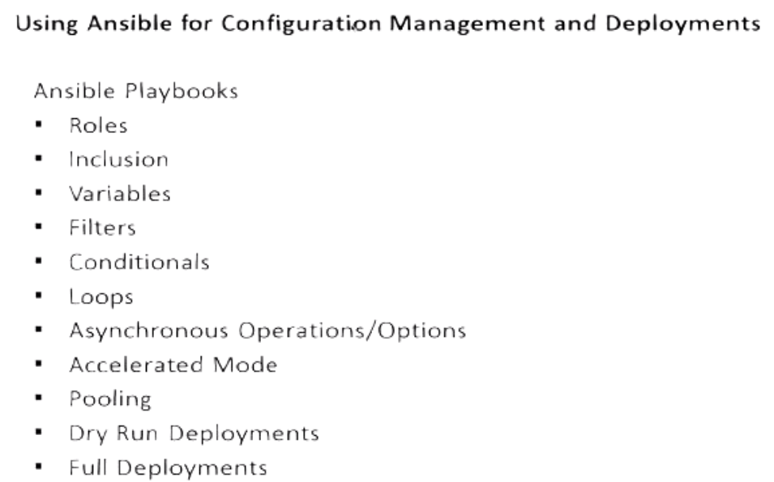

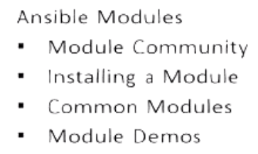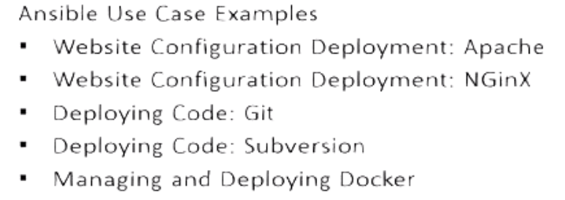

**Ansible Playbooks** are one or more scripts, which tell Ansible:

What to do

Where to do

How to do

What can be used to do it?

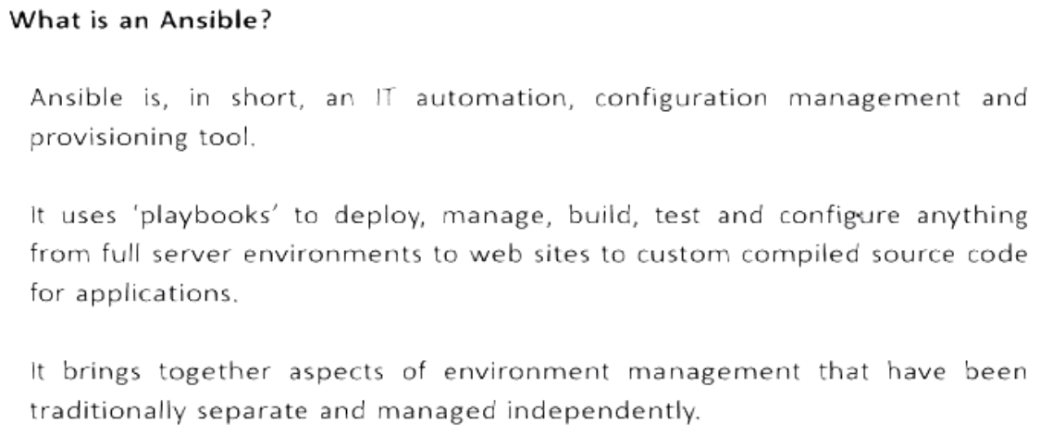

One stop shot for managing, deploying env..whether in Virtual, AWS, Azure or Openstack.

Configuring everything from OS deployment, Contsant deployment and delivery of Code Updates , builds

With Jenkins: In order to configure, Build, Test

With Docker: deploying and configuring Enterprise env. 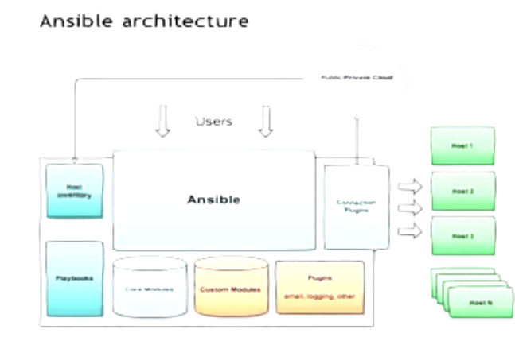

Every client can be a server.. Every server can be a client.. Config.

Server for 1 Config, Can be a client for other Config.

🡪With Ansible, we can make server deployment exactly same and consistent.

If we deploy webserver on centos7, every server is configured exactly same because same configuration is sent to each to these servers, when it spin up.

-- This ensures we haven’t introduced anything by manual configuration.. Which may cause hardly to troubleshoot.

--Additionally, may make up into system or environment issue. If system is mis-behaving there is no need to troubleshoot, we can reapply configuration. Pull node completely out.

Ex: in a webserver env.., have 10 nodes in cluster.One node is misbehaving, 9 are fine.

There is no need to troubleshoot that whay node is misbehaving , I can pullout—destroy, and redeploy fresh instance and put in my cluster.. My consistent config. Is going to heal my new node..

__--🡪 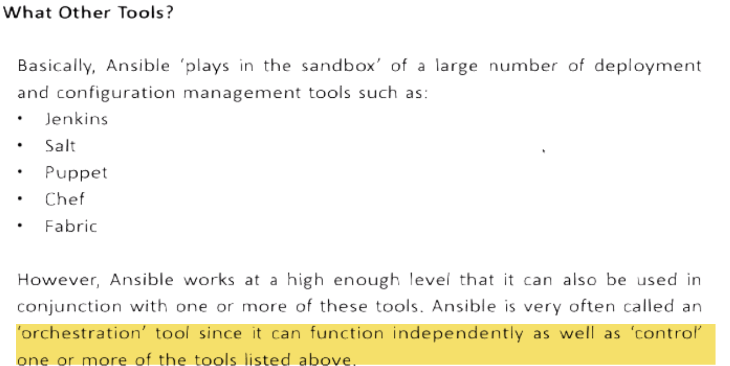

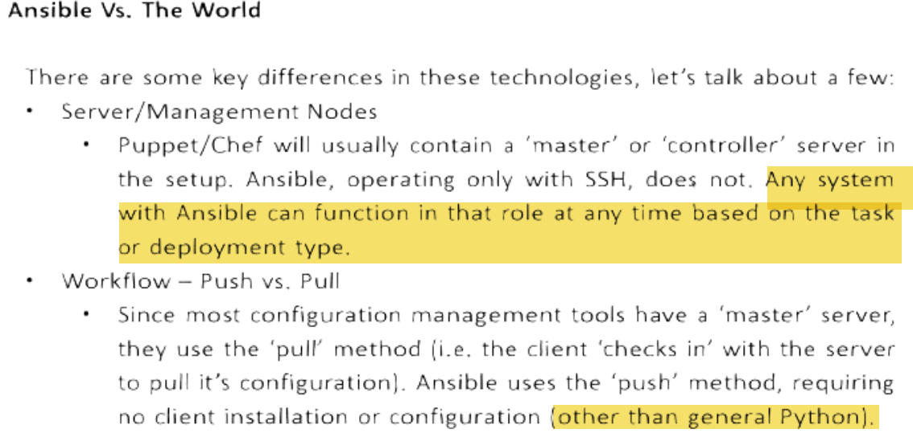 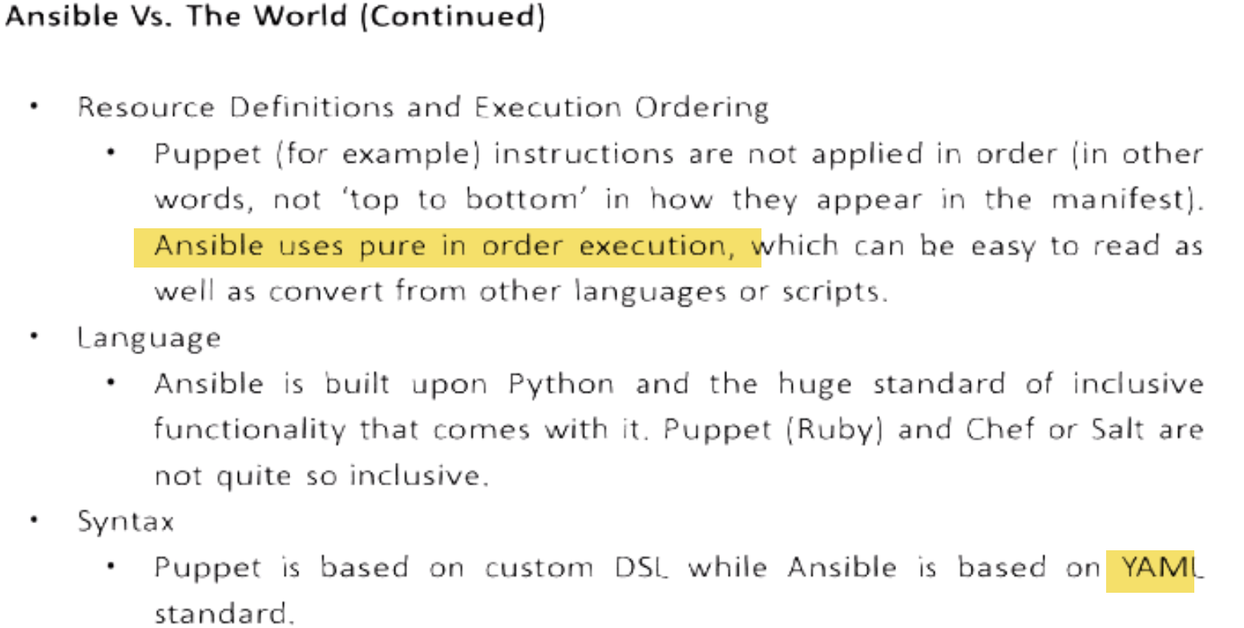





 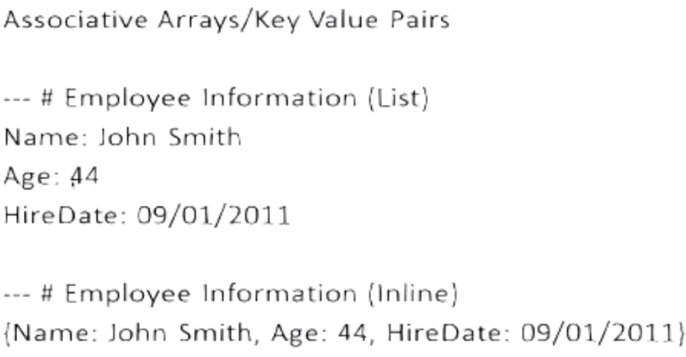



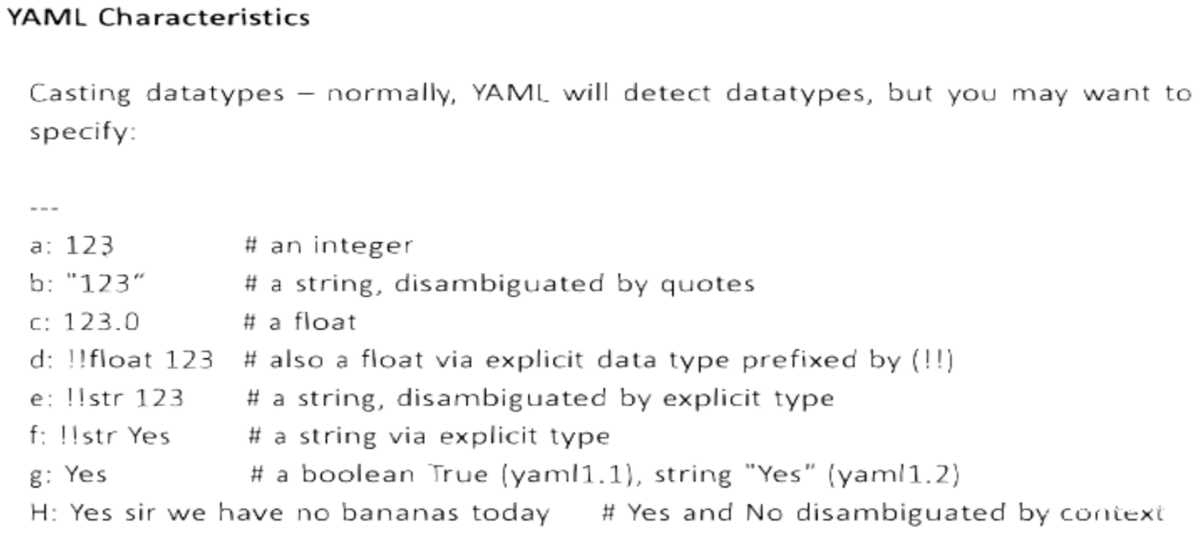

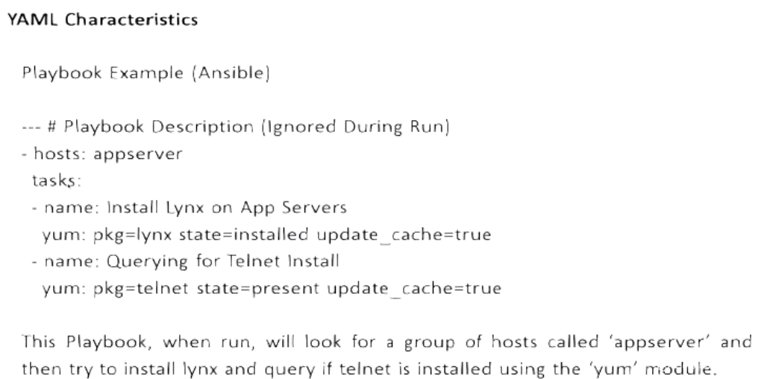

**HELP**

Man Ansible

Man Ansible-doc

Ansible-doc –list

Ansible-doc –list>list---will be helpful

Ansible-doc ec2

**Ansibe tower-🡪enterprise edition🡪reports**



**Use python 2.6 ..Not python 3(Can cause problems)**

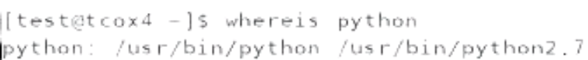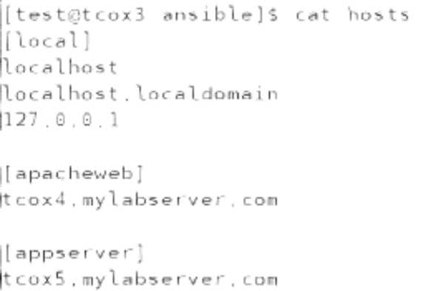 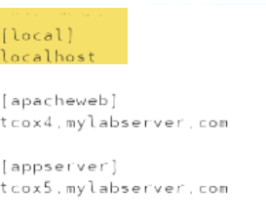

**Note:**

Ansible Config. Under /etc/ansible

Recommend: Setup shared n/w drive so that we can execute playbooks from any.

Ansible can be configured to run by root or user.

🡪 When we refer something locally, no eed to refer 3times in example..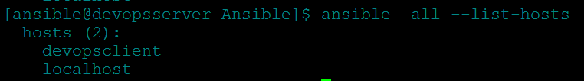

--🡪Override hosts file---Create hosts file at any place

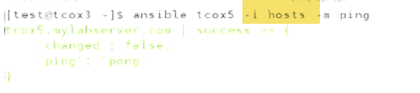

🡪How to overrirde /etc/ansible/ansible.cfg???

* IF I DON’T HAVE SUDO PRIVILEGES TO CHANGE ANSIBLE CONFIG FILE
* What if I want to define group of hosts that include in main hosts file

🡪1.) a.)Instead of 

We can copy ansible.cfg locally and

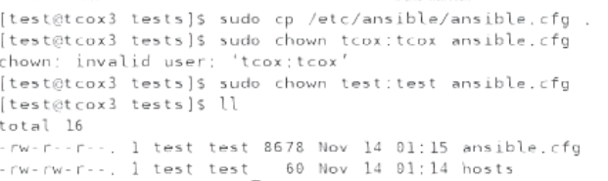

b.) Change inventory path to ./hosts (Current dir…hosts file)



c.) It will use current dir. hosts file

2.) If we change inventory path, need to set variable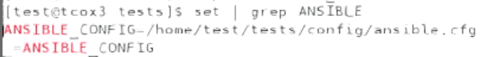

So 1st look for ANSIBLE_CONFIG env.

Variable..2nd place current dir, wherever I ‘m running command

3rd: home dir of user running command

4th: /etc/ansible/ansible.cfg

🡪Roles

Ansible.cfg





No password will be asked, when running using sudo



--🡪

Check if nodes have telnet installed

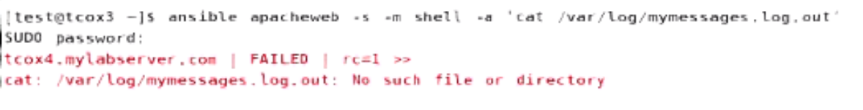

If command fails…RED

-🡪Check if ansible is able to run commands.

Ansible gather_facts using setup

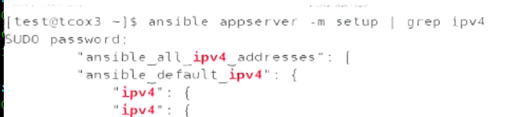

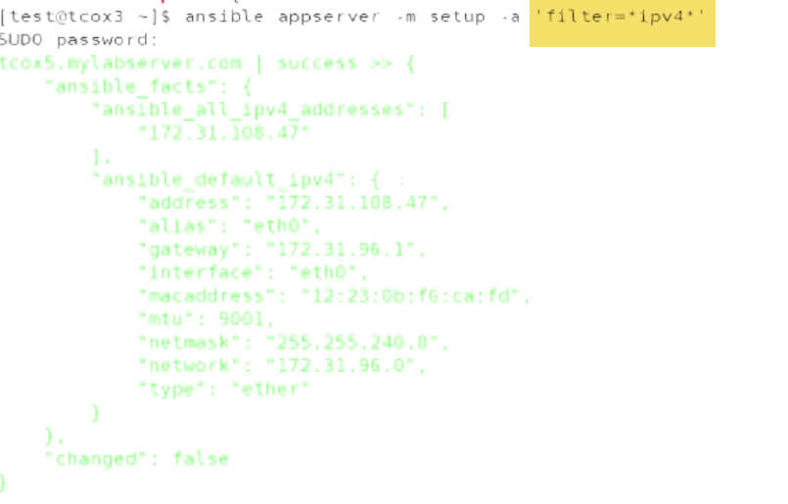

**\*ipv4\***

**-🡪**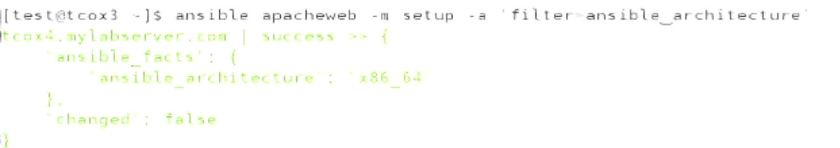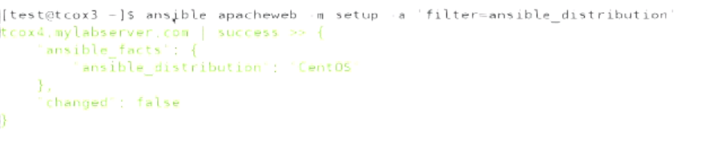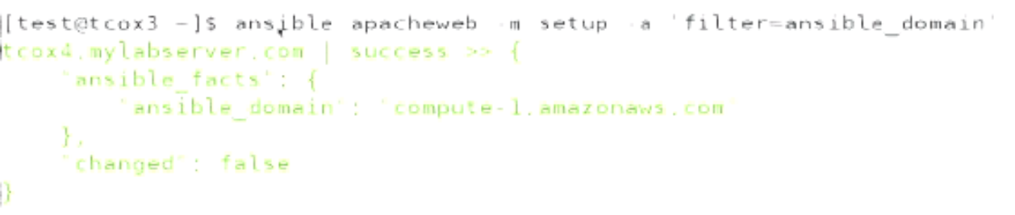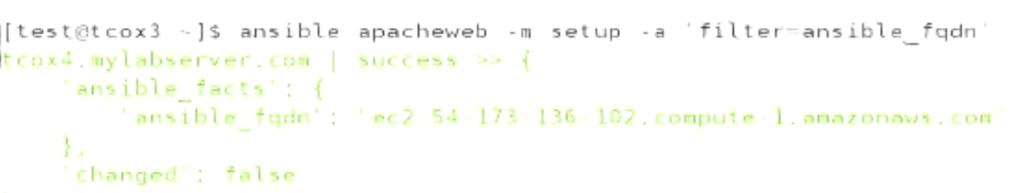



**-🡪**

**How to convert this into playbook???**

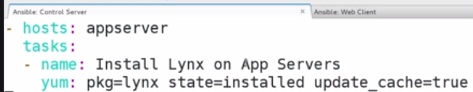

**🡪 If we want to run yum update.**

**We can do using cron job**

**-🡪Variable(Included as section vs included in file)**

Ansible execute from top to bottom.

Variables should me defined on top under vars section..Otherwise undefined

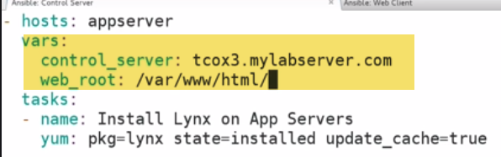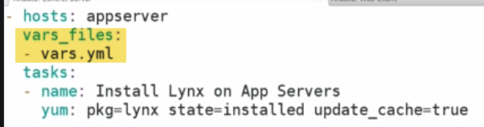

I can have variable defined in vars section as well..

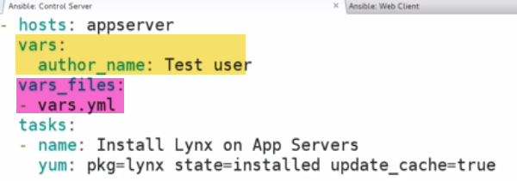

-🡪**Tells who(test user) to run, how to run(sudo) at target**

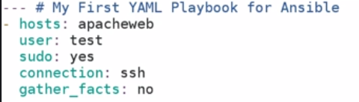

🡪Playbook-1:

1.)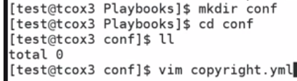 

2.) 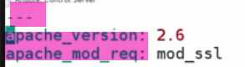

3.) 

It have 3 types of vars:

* var(within playbook)
* Var: outside(external file)
* Var: Populated at run-time prompted by ansible itself

Issue: 

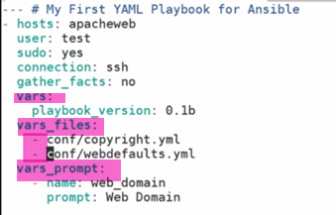

Anything that is external we have to use – before…Local not required.

-🡪

Number of modules:



Tasks: What we are going to do/actions in playbook.

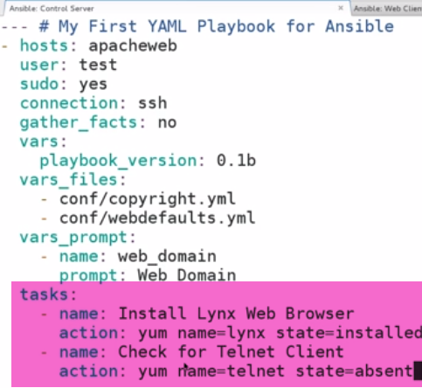

-🡪**Handlers:**

1.) Ability to notify when something happens

2.) Execute another set of tasks.

Although not a task, it’s a kind of own handler.

**Ex: install httpd and check if service is installed:**

Don’t configure handler if we want to run everytime in playbook..(Handlers run only 1st time) 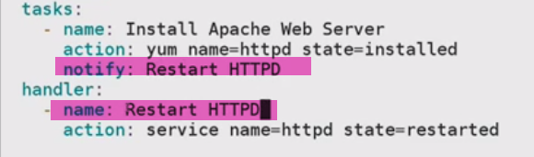

-🡪

We can specify hosts like an array:



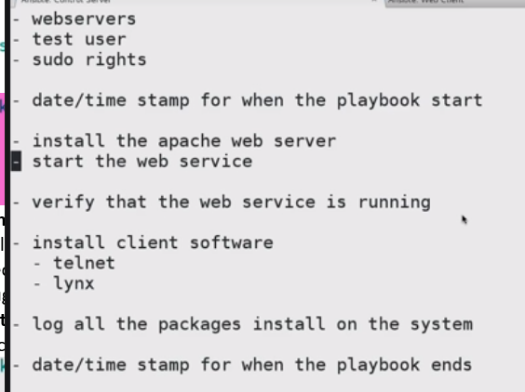--🡪Webserver.txt

**-**🡪**59-512-1 - The 'Setup' Module**

This module is automatically called by playbooks to **gather useful variables about remote hosts that can be used in playbooks.**

**Most common facts available in machines.**

It will bring whole bunch of facts…Difficult to read.SO doing on 1 client m/c only

-🡪 all clients and all env.. tough to read at a time



**---Let’s say I want to install apache. I want to know about distribution and version available across all servers configured in hosts file.**

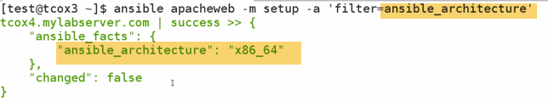

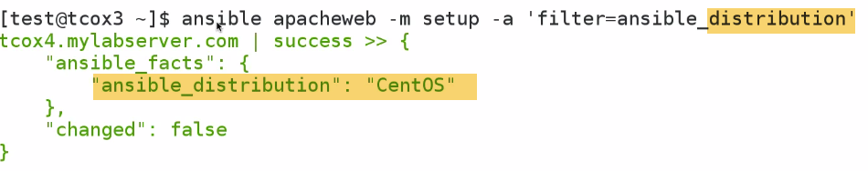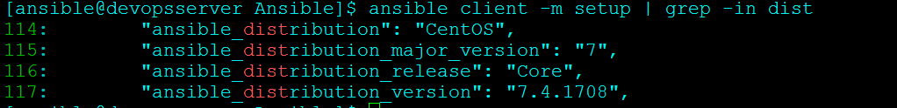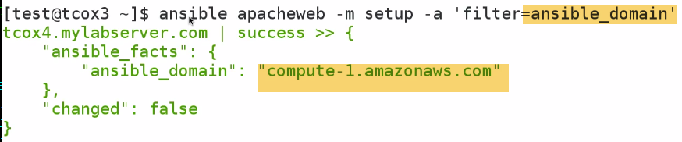

It is because Linux academy servers running on aws..

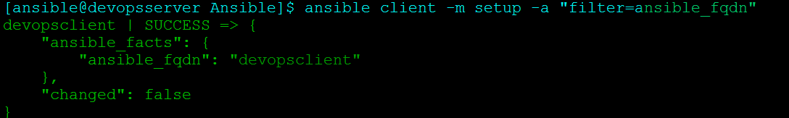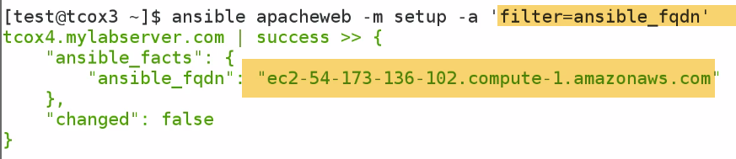

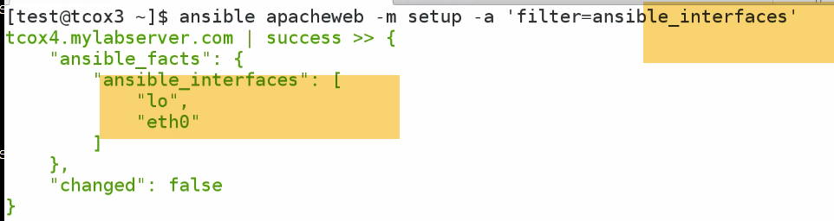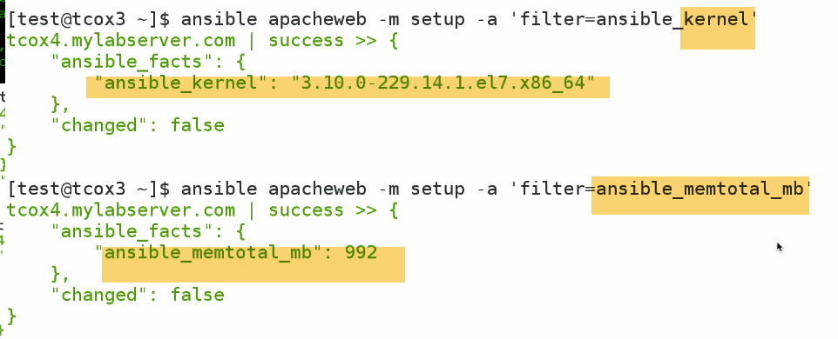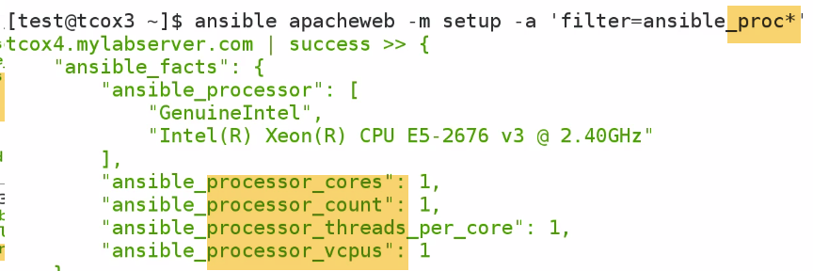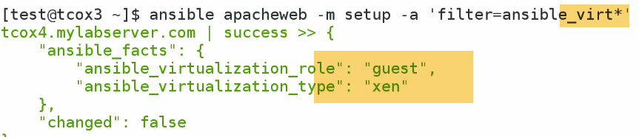

Note: this info. Are gathered by python.

FILE, COPY,COMMAND modules allows us to do things with files or dir..

**-🡪59-512-2 - The 'File' Module**

Sets attributes of files, symlinks, and directories, or removes files/symlinks/directories. Many other modules

support the same options as the `file' module - including [copy], [template], and [assemble].

**---Interact with File system. Pull info about fstab**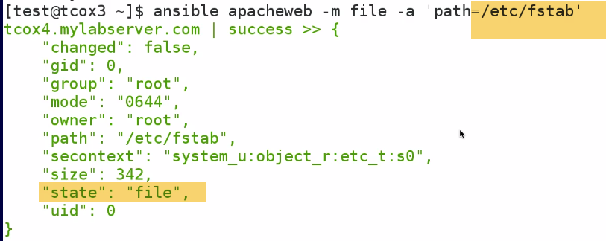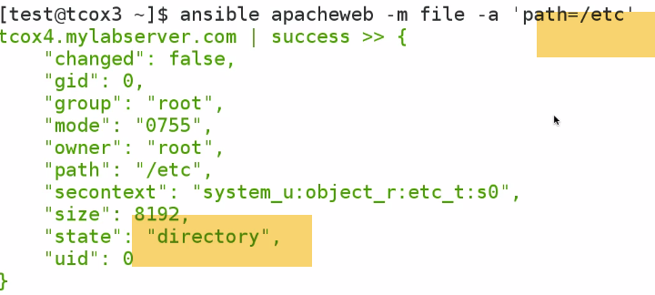

---Change ownership of file, copy file, setup new dir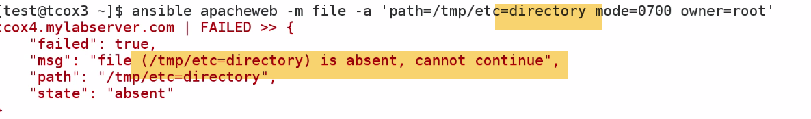

Directort /tmp/etc doesn’t exist..So we have to use state=directory (create a directory if it doesn't exist) 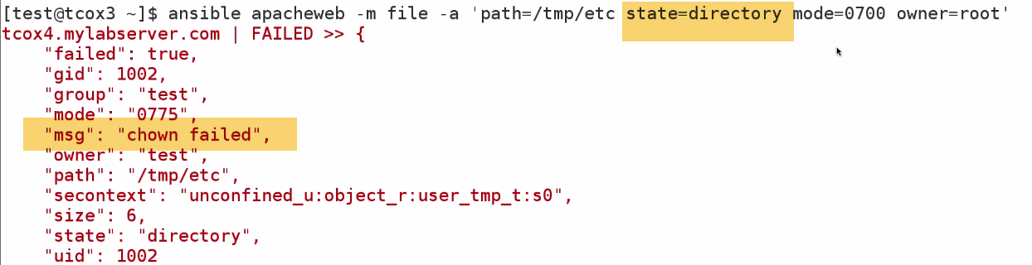

Now again, chown failed…because we didn’t execute as sudo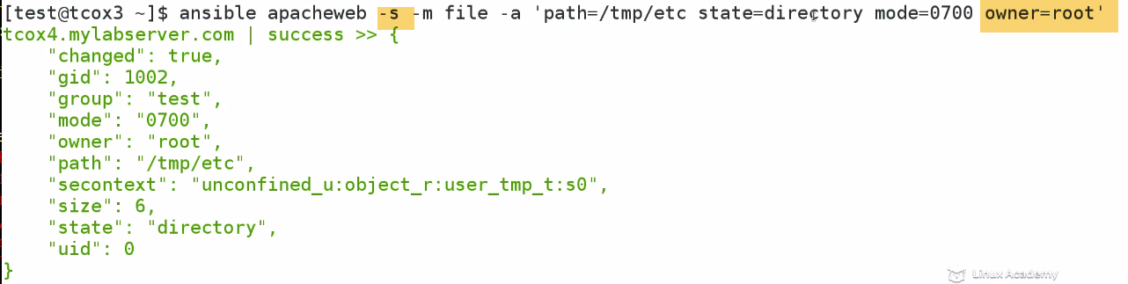

**COPY Module:**

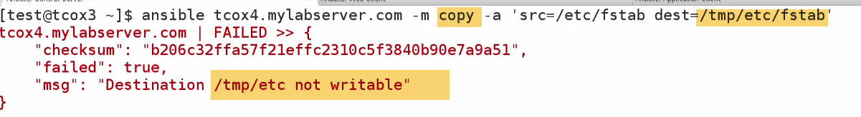

/tmp/etc/---Owned by root here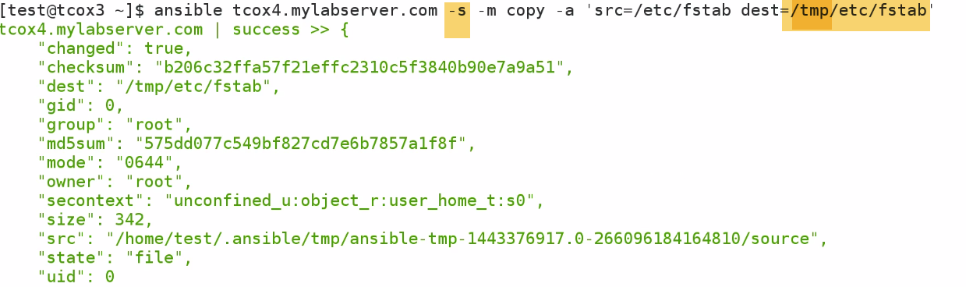

**COMMAND:**







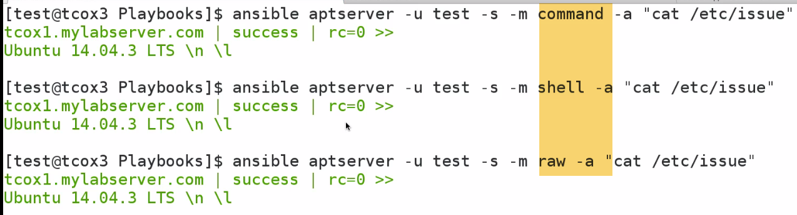

All these 3 giving same o/p. All goes to remote server, executing arbitrary command..

**Shell and command adv.:** There are specific functions that allows shell and command to register o/p to pass in particular directory...

**PAUSE**

It stops execution of playbook either a key is pressed for certain amount of time.

Generally we provide when a user need confirmation to continue..

Ex: 1.)We want to Deploy a webserver... but we want user to test webserver, before we continue on rest of playbook that do other things.

2.) We can use pause module, So that we can Pause without killing or running multiple jobs which needs user input.

3.) We can use Prompt and get information about a variable

It is never used a much as wait-for module, because it is less interactive method of pausing playbook.

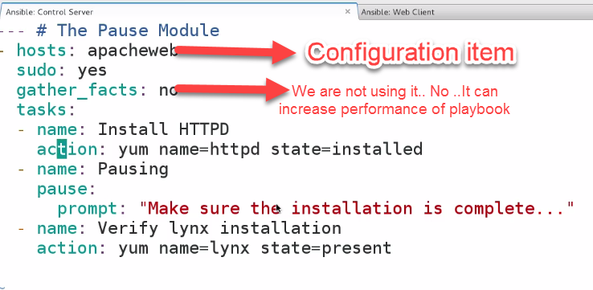 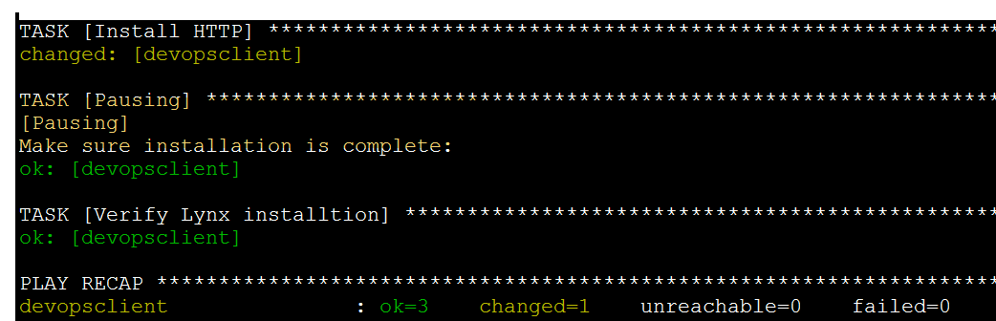

Pause…

Also, lynx already installed... So change=1 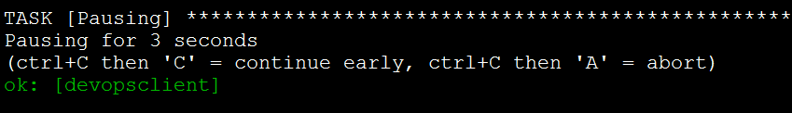

**WAIT_FOR**

--Wait for some dependency like file or restore database or port to be listening.

Will not continue playbook until port accepts remote connection.

Now, Install tomcat, which by default listens on port 8080 once started. Use playbook Pause and wait until we go over server we deploy tomcat, start up and verify listening on port 8080

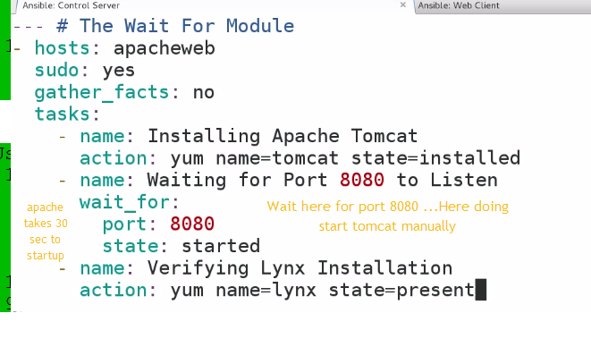

Apache takes 30 sec to startup like:

Waiting for DB to connect

Wait for large ends memory

Caching before to start

- state

either `present', `started', or `stopped', `absent', or `drained'

**When checking a port `started' will ensure the port is open,** `stopped' will check that it is closed, `drained' will check for active connections

When checking for a file or a search string `present' or `started' will ensure that the file or string is

present before continuing, `absent' will check that file is absent or removed

(Choices: present, started, stopped, absent, drained)[Default: started]

WAIT_FOR is common methods for waiting for an event to take place in playbook

**'Yum' Module**

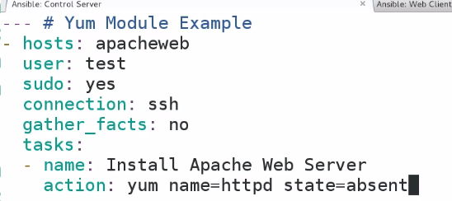

Used for package manipulation of remote clients

Query, remove, install pkgs

State=present or installed—any one

Remove🡪absent

Update🡪latest

 -🡪yum upgrade

- name: install the latest version of Apache from the testing repo

yum:

name: httpd

enablerepo: testing

state: present

**- update_cache**

Force yum to check if cache is out of date and redownload if needed. Has an effect only if state is

`present' or `latest'.

(Choices: yes, no)[Default: no]

**APT MODULE**

**---Setup Ubuntu server on hosts file** 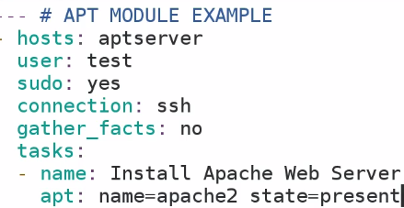

Upgrade🡪

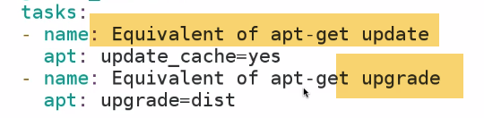

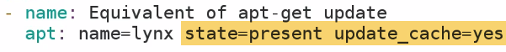

---Install links and do sudo apt-get update

SERVICE MODULES

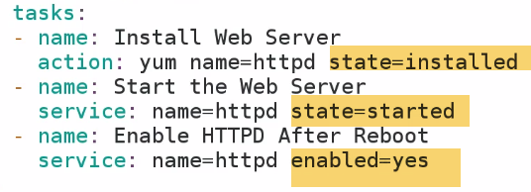

Enable/Disable services for entire environment. If I have a host group environment DEV.

I make change for one configuration; can be applied to all in DEV env...

**COPY MODULE**

COPY files from local to remote including setting of user, group ownership, R/W

Backup files

**1.)**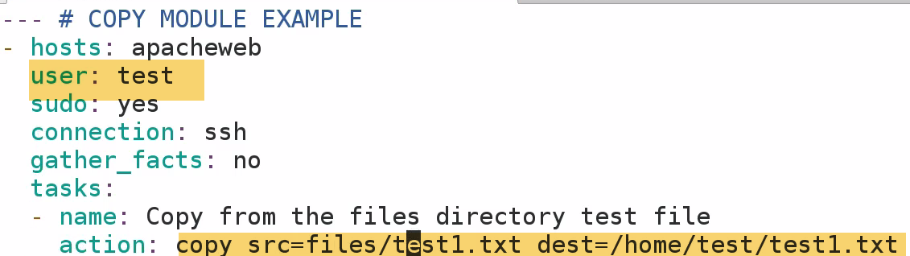

**One thing need to worry is permissions is on root**

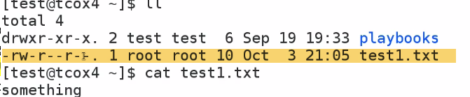

**2.)**

 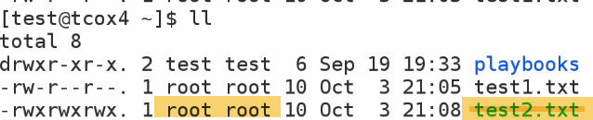

1. 



-🡪What if we want to copy files and don’t want to loose changes

On Client m/c create text4.txt

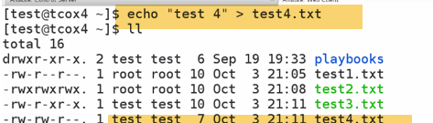 

Make backup of files, that we might accidentally overwrite if exists in destination system 

**Get backup file with file.Timestamp**

Particular useful in builds, checking code from github and copying config. Files when changed in dir inside group f services.

**Ex: When changed apache vhost config. for particular website and have 5 webservers in cluster..We can use single copy command and copy that to all individual servers. Then, use service module to restart service on all webservers**

**-🡪59-512-9 - The 'Command' Module**

Fills in.., when Used to run commands when modules doesn’t exist by using builtin shell over ssh.

We can used to install modules, log files etc..

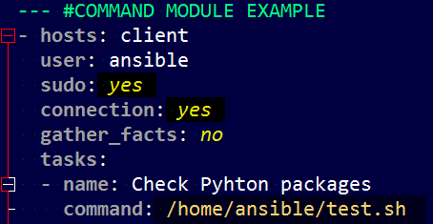 

Here we are sying: TO run command from a particular directoery..

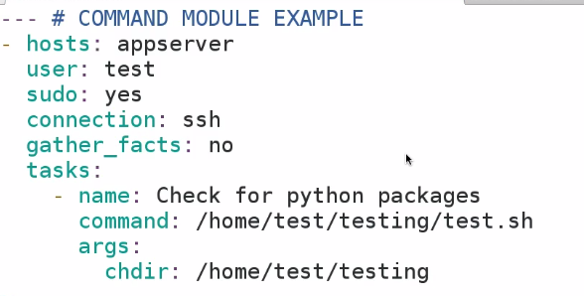

- chdir

**cd into this directory before running the command**

**---CRON MODULE:**

If not given will run every day of month

Every week of month @1 am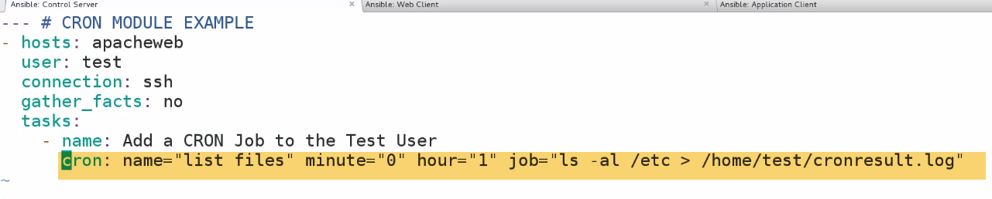

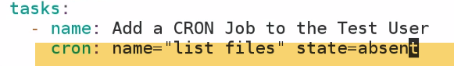

DB backup, user refreshes, permissions

-🡪**Debug MODULE**

**Troubleshoot, what values set to variables..**

1.)

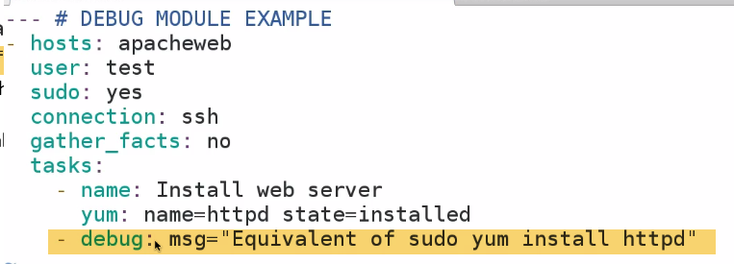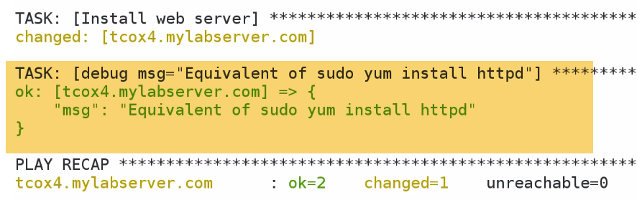

It will show what tasks is done in JSAON format

2.) How long system is UP??

/usr/bin/uptime-🡪Wouldn’t seen on screen even if succesfully run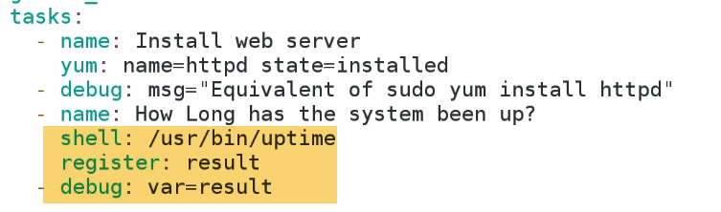

**-🡪FETCH MODULE**

This module works like [copy], but in reverse. It is used for fetching files from remote machines and storing them

locally in a file tree, organized by hostname. **Note that this module is written to transfer log files that might**

**not be present, so a missing remote file won't be an error unless fail_on_missing is set to 'yes'.** 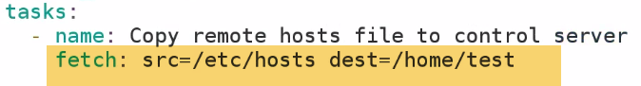

It will create a directory devopsclinet folder in /home/test user

And then create /etc/hosts file in it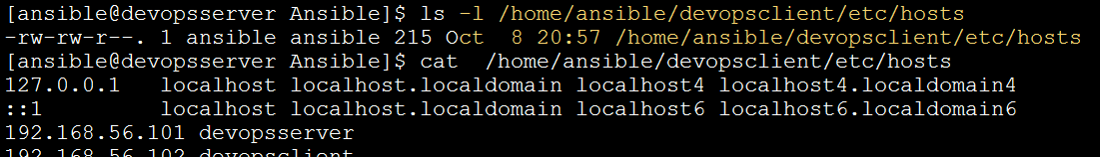

2.)



**Noe: Gather_facts=yes: Because I’m using ansible_hostname system variable.**

**If hostname is changed since last time, facts will be gathered., it pulls correct hostname**



**It created a prefix-hostname file**

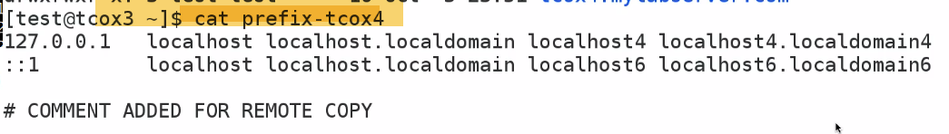

**By indicating name in direct path and flat=yes**

**Take that hosts file, name it locally prefix-hostname.That allows to bypass automatic creation of path ---(Hostname, and remote directory)..So that we could have single file prefix-hostname.**

**3.) With** 

**It will gather all hosts file**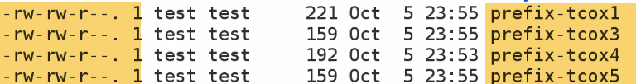

**On all environments..**

**-🡪USER MODULE**

* We want to create user, after we installed apache web server.
* We want twant to set to particular owner for apache service
* We want to run somethiing as particular user

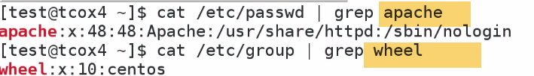

1. 

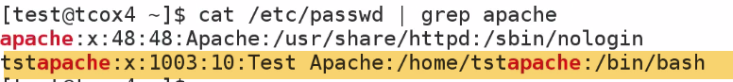

1. 
2. 

Account to expire at certain date.

Set SSH keys for particular user

We have setup an application, and want to be run/owned by particular user

/var/www/html ---owned by user

**-🡪AT MODULE**

Execute at some time in future, but not exist perpectually.

Run, Forget it later.

- command: A command to be executed in the future.. [Default: None]

= count: The count of units in the future to execute the command or script file.

= units: The type of units in the future to execute the command or script file.

(Choices: minutes, hours, days, weeks)

EXAMPLES:

# Schedule a **command to execute in 20 minutes** as root.

command: "ls -d / > /dev/null"

count: 20

units: minutes

1.) 

**1 min. from now, because we have indicated conunt=1**

**2.)**

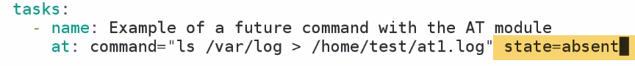 

**-🡪DNF MODULE**

**Specific to redhat/centos>= 7…Minimal not installed.**

**Replace yum module**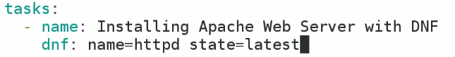

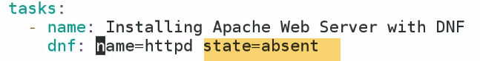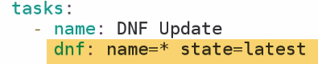

**-🡪Install Group packages**

**-🡪APACHE2 MODULE**

**Ability to enable/disable specific module in Apache web server.**

1. **On 14.04 Ubuntu node, with Apache installed, and running**



1. 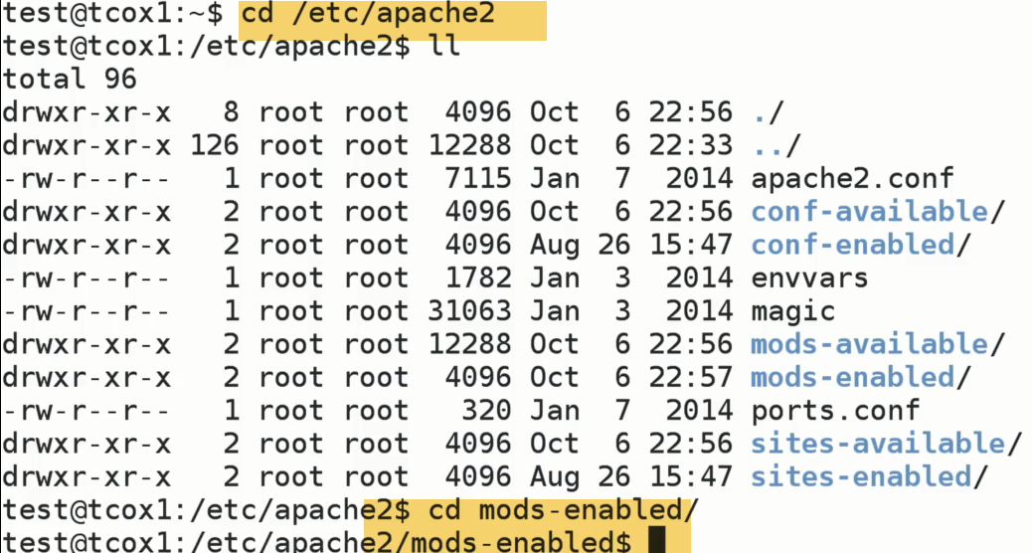

**Under /etc/apache2 there is mods-enabled directory**

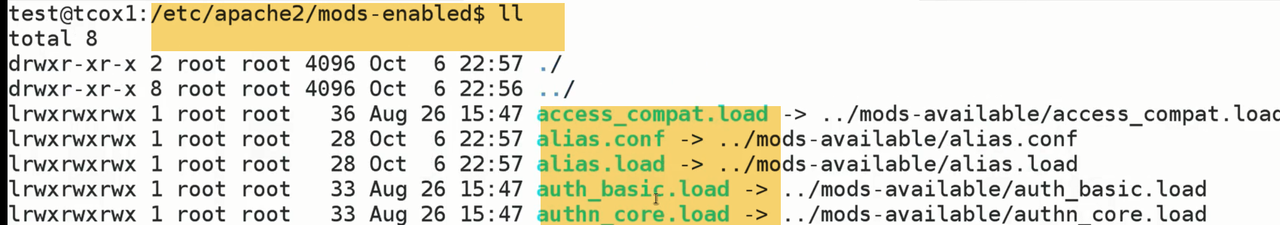

**Shows list on modules available and linked**

1. **We re going to pick alias here..**

**Alias reads from mods-available directory, so that it knows how to load into memory for supporting Apache web server.**

**Note: Apache2 Module applicable for Ubuntu/Debian based systems.Because module mgmt for Centos is either within httpd file config. directly or externalized if we change those values.**

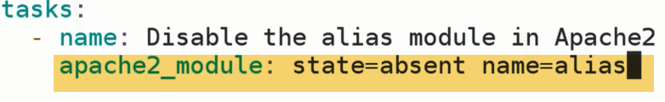

No need to specify fully qualified name.Ansible is smart enough

1. ansibleplyabook ….



Alias modules is not seen now.

**-🡪'SetFact' Module**

When we don’t want system facts in playbook, we turn them off to save time.

Howover we want to set facts that lasts b/w playbook for particular hosts or group of hosts.

**Variables set in playbook only persist for playbook thaey are member of.However, if we set fact for particylaar host with in playbook, then particular fact will be applied to subsiquent playbook, Until fact is set to somethin else.That fact is simply a variable.**

**Setting fact gathered through facts from remote system from within playbook.We are going to set facts to something else.But going to set a fact that persist across playbooks.**

**Stat Module**

Retrieves facts for a file similar to the linux/unix 'stat' command.

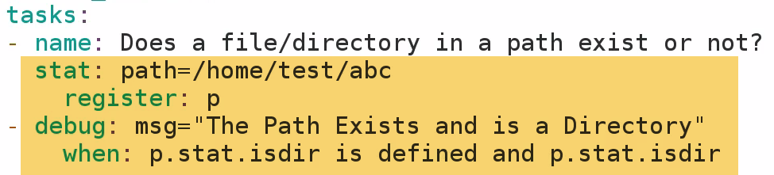



Skipping because dir. Doesn’t exist and failed test..

2.) 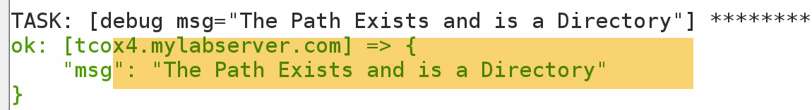

3.)We can see if that is a link

.stat.islink

.stat.isfile

If we are deploying a piece of software, and it is generating a errr log to a file to particular location on remote location.

Based on that info, we may redploy application, if we find particular bug..Because log file exists indictaes s/w to be updated.

We can test if file/dir exists and conditionally executes other parts of playbook.Again, if we look at aprticular modules.

This module checks for existence of files and dir..and conditionally executes other complex modules in playbook.

So if we want to use stat command, rather than pulling back info. Using shell Module..We can use STAT command

**-🡪 'Script' Module**

Simply execute script on remote host/hosts

**We can use COPY module to copy file form Control server to client server, and then we can use SHELL module to run remotely. 2 steps:**

**But fortunately, One module that combines both functionality—SCRIPT module**

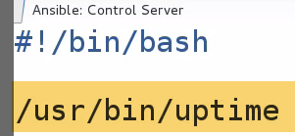

**Script.yaml takes local script system_uptime.sh and run on remote system.**

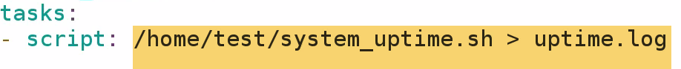

**Verify uptime.log created**

**# Run a script that creates a file, but only if the file is not yet created**



**- script: /some/local/create_file.sh --some-arguments 1234**

**args:**

**creates: /the/created/file.txt**

**In this case, Uptime.log file alreasy created…So it wont create again**

**-🡪GIT MODULE**

Interact with git-repo to build codes to other servers.**Core Modules for ansible configuration.**

- version

What version of the repository to check out. This can be the the literal string `HEAD', a branch name, a

tag name. It can also be a `SHA-1' hash, in which case `refspec' needs to be specified if the given revision

is not already available. [Default: HEAD]

- update

If `no', do not retrieve new revisions from the origin repository. (Choices: yes, no)[Default: yes]

- clone

If `no', do not clone the repository if it does not exist locally. (Choices: yes, no)[Default: yes]



**59-513-1 - Galaxy Introduction and Usage**

There are number of previously developed roles that can be used to use, or change as required. **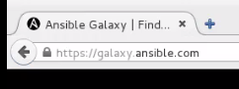****--empty**

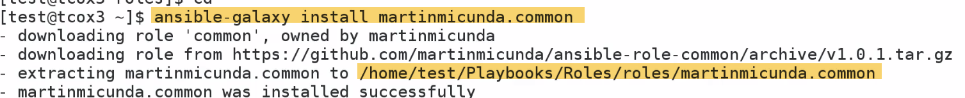

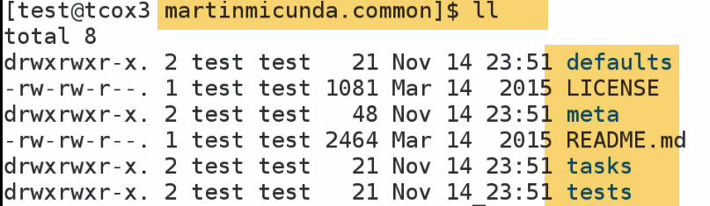

**59-519-1 - Ansible Command Line - Installing Packages**

Installing particular service across all servers..

If we have heterogeneous environments, we will have different packages for different environment.

Apache on Ubuntu-debian –>Apache2, Centos-yum ->httpd.

How can I divide that?

Ansible 2.0 and above there is package management system that will call appropriate apt or yum repos.

-u🡪user



**59-519-2 - Ansible Command Line - Services and Hosts**

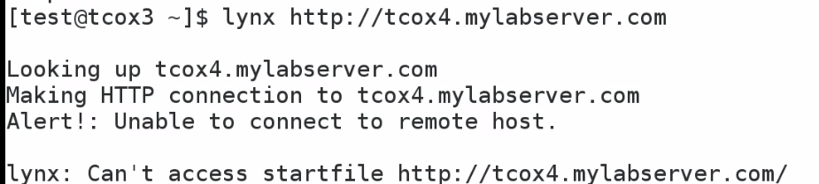

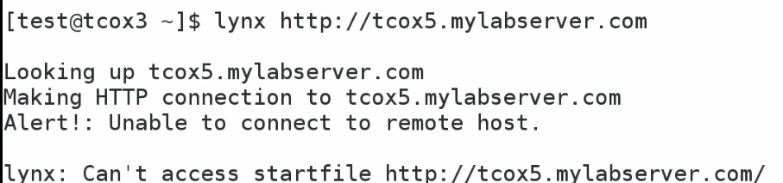

**-🡪59-519-7 - Ansible Command Line - Output Tree**

If we are managing large env.., we may have one control server that does one or one builds (mostly scheduled builds).We will get output back on JSON format depending on how to execute playbook.

We can take output and send to logfile..which will give us status of job for one or more jobs…

**Now. We will see…take directory as argument, and separate output by hosts**



**It will create directory install-results, also shows o/p on screen (like tee command)**

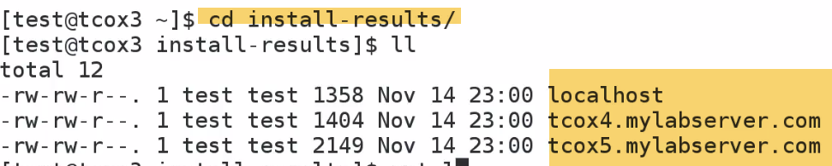



**NAMe Dircetory-🡪Date_time_scriptname_Pkginstalled.**

**This will give results by host**

**When I do auditing, json output into dB or format output on webpage will give results**

**-🡪59-519-4 - Ansible Command Line - Managing Users**

**Add account name –same all servers**



**We can also set gid and key-phrase**

**This will not delete files and folders created by user**



**Delete including user files**

**-**🡪**59-519-6 - Ansible Command Line - Running Arbitrary Commands**

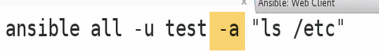

**Execute only command**

**59-519-5 - Ansible Command Line - Create and Manage Cron Jobs**

**AT: Run Only once –single min to 24 hrs from now**

**Cron: Run at midnight on day..**

* **Clean Log files..**
* **Restart webserver**



**Every week, every month, every year**

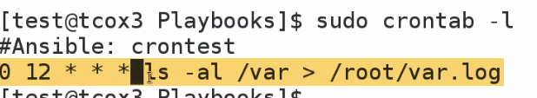





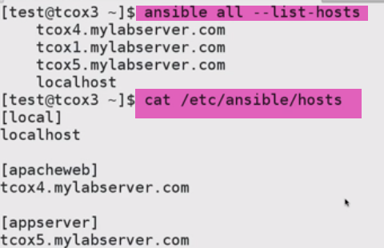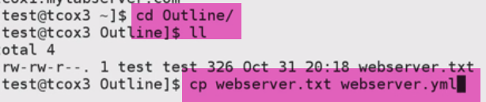-🡪rename to yaml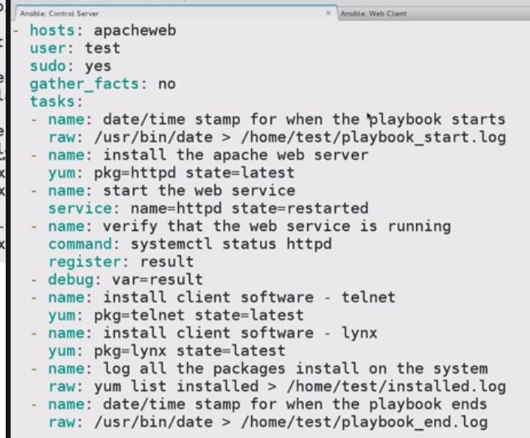

Check Syntax:



-🡪Running Playbook as a Dry RUN:

--check : connect to remote hosts. Look for what it will do on remote hosts using everyone of taks.., and what result might be..

Result: Wouldn’t be live..(Really wount be running commands)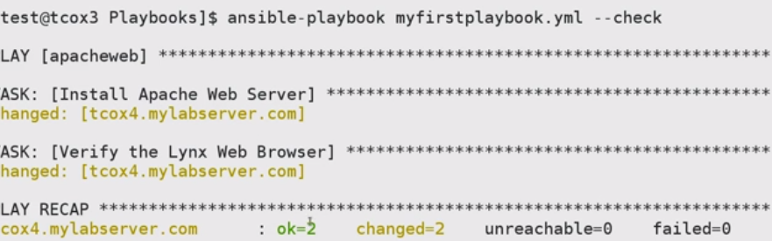

Change here=🡺 will be going to change if executed

OK=2, Change=2🡪 Install apache, lynx

Ok=2, Change=1🡪 IF apache installed, lynx to install

Ok=2, Change-1🡪 Lynx installed, Apache to install

Ok=2, Change=0🡪 both installed